- Dashbord is fine
- While we are going in company 2nd point its little loading for 4-5 sec.
- Company edit please remove the contact number compulsory mark.
- Filed indexing not working as per our index number its same as per old in all companies
- 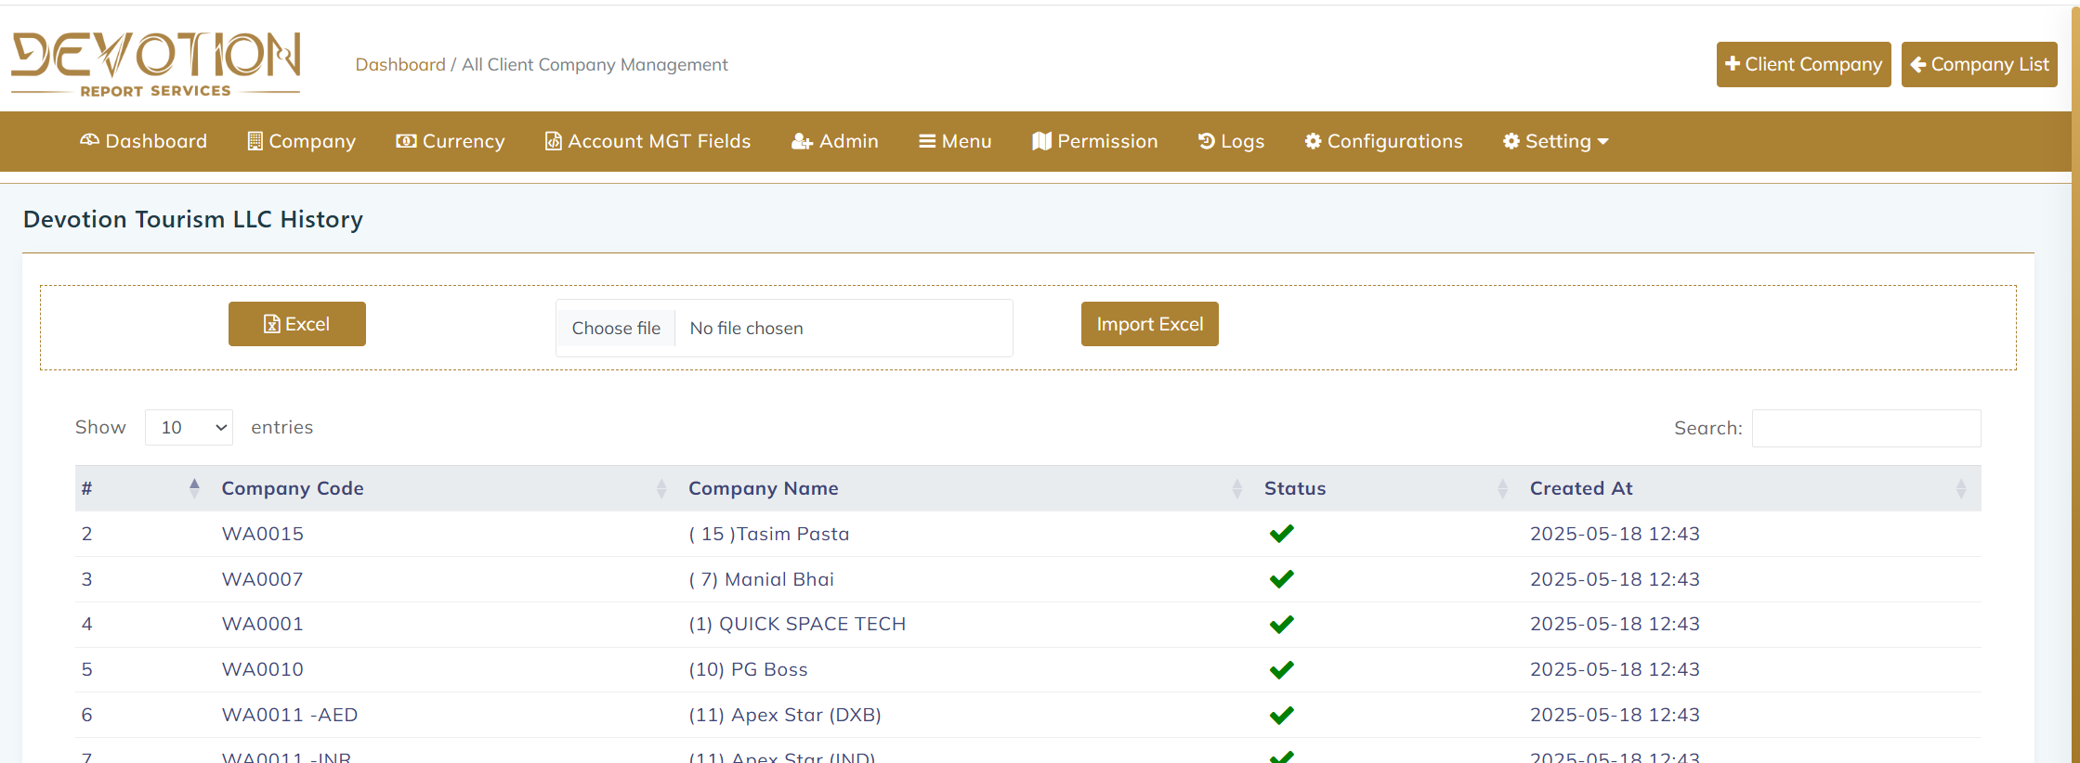
Client company adding option no upper then gilden menu line
- Need option for download client list in every company
- Bank account need edit and delete option (But if there is any entry with that perticuler account its not allowed to del)
- While we are going back full page refeshering I want at the same page after edit or when I going back to the tab.
- 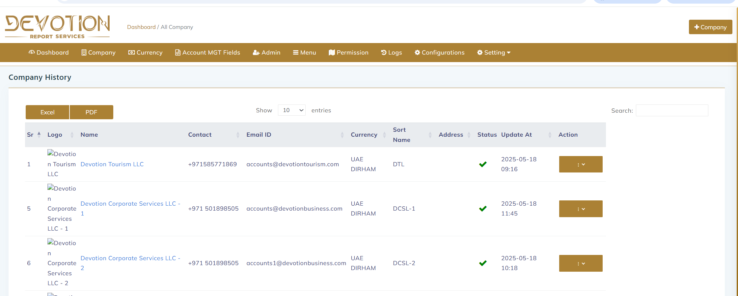
Some time payout is not working proper u can see SS.
- 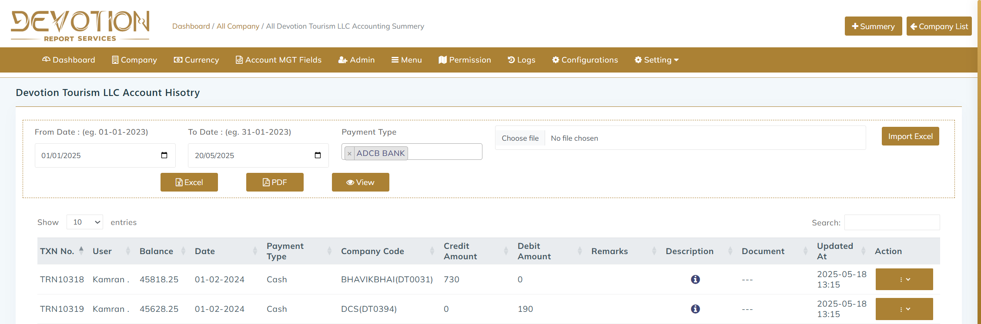
I am unable to download exle or pdf and also unable to view particular payment type.
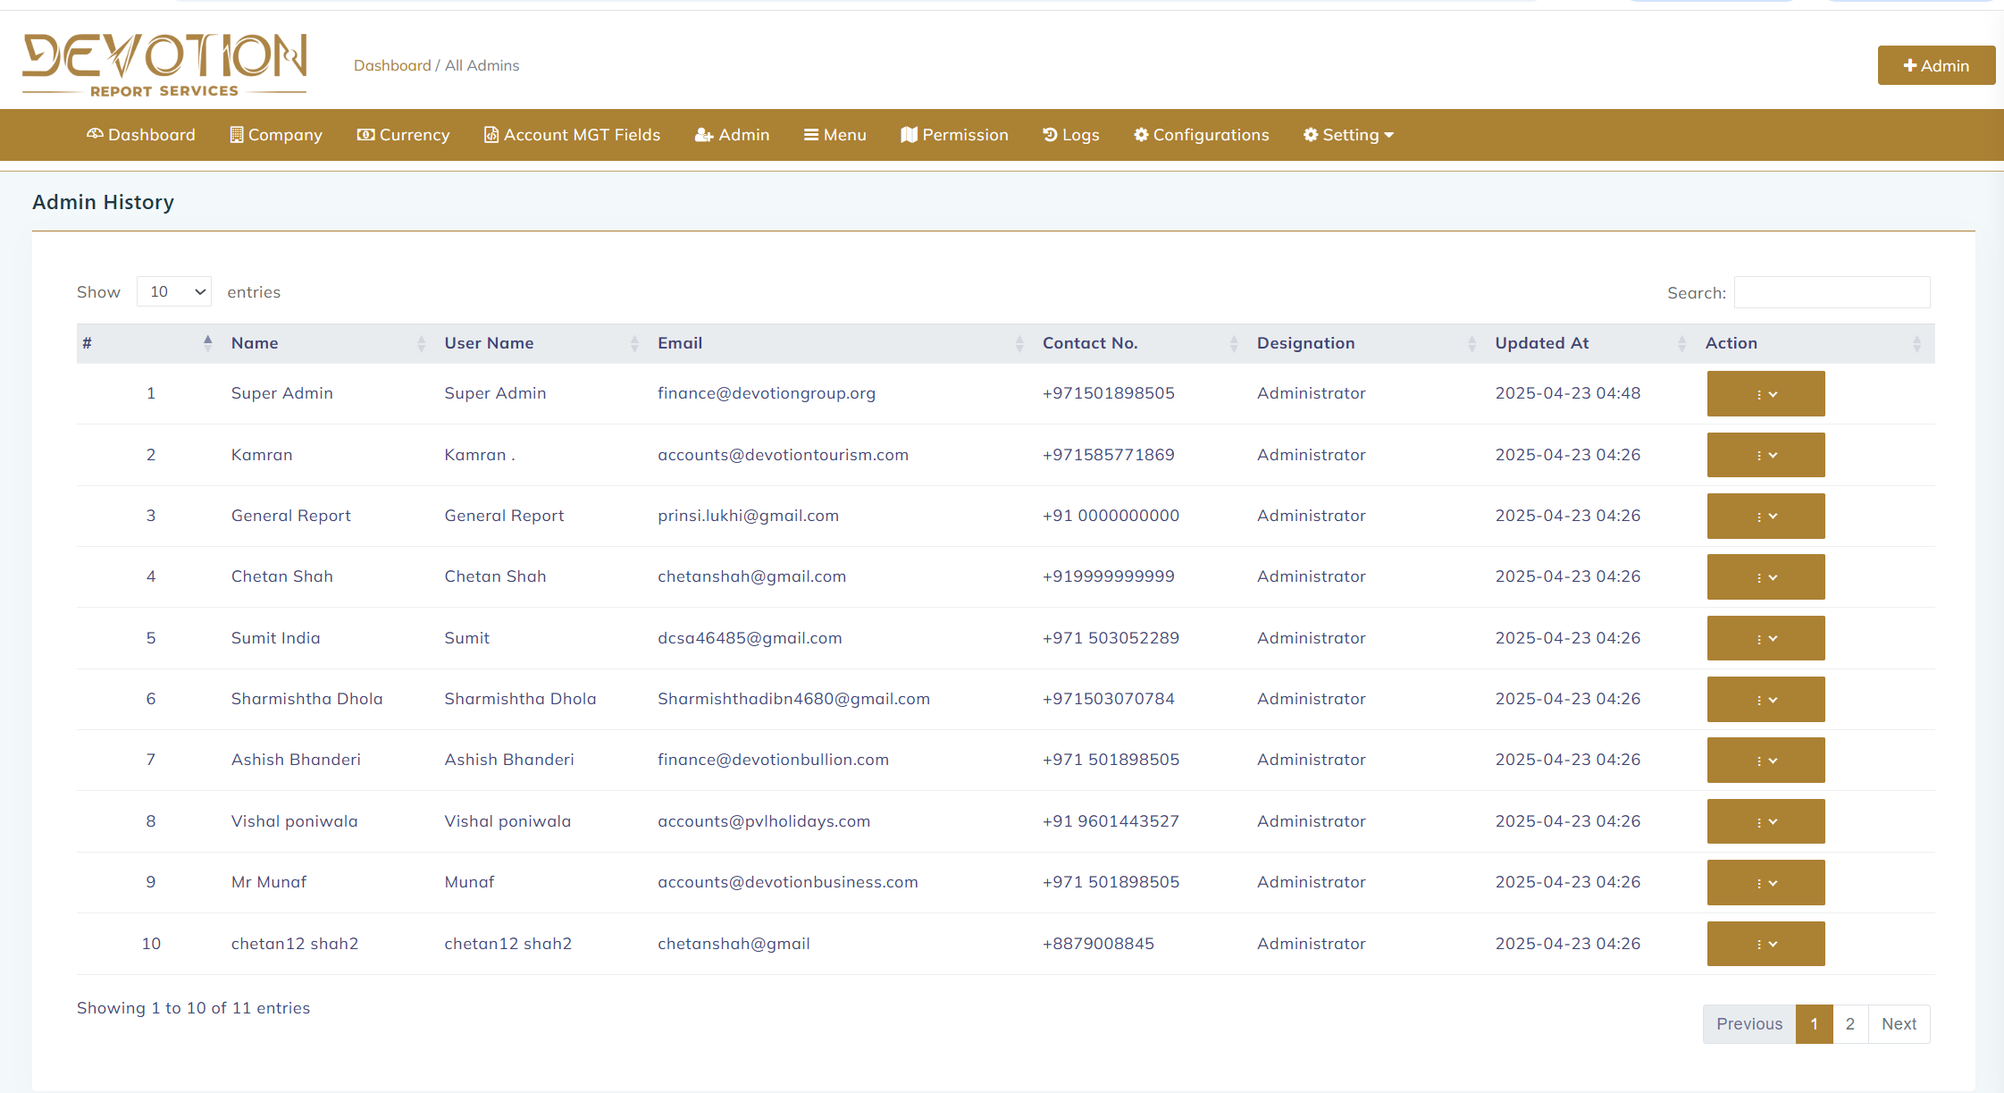
- Remove admin name make it user.
- 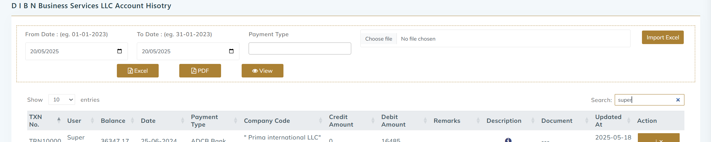
User name taking wrong not as per previous data
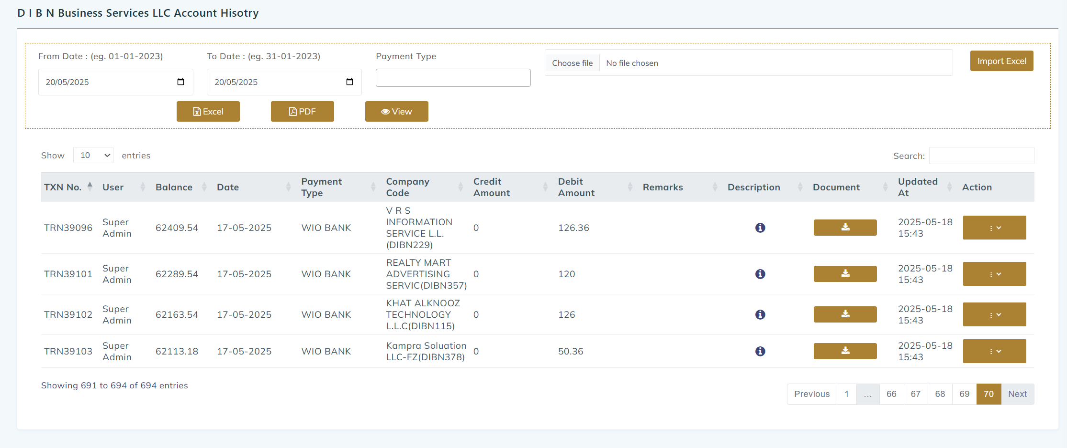
13, I need proper view description same as per old .
14. Entry editing taking time .
15. 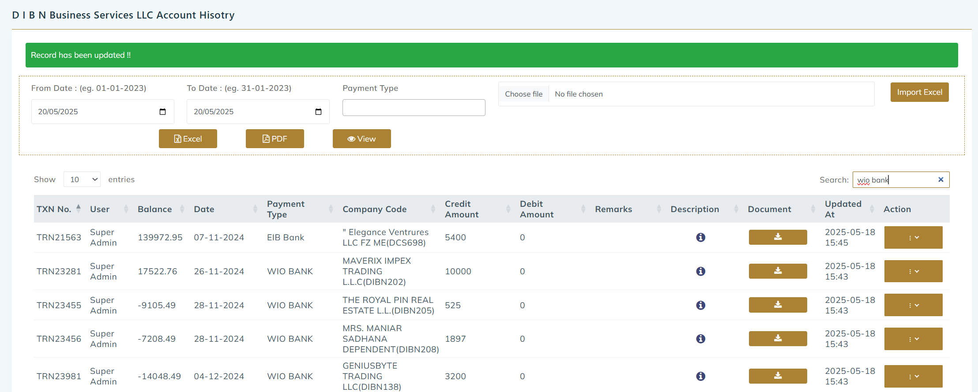
In this dibn company there not any eib bank how its come in payment type.
16. in searching not all data comes.
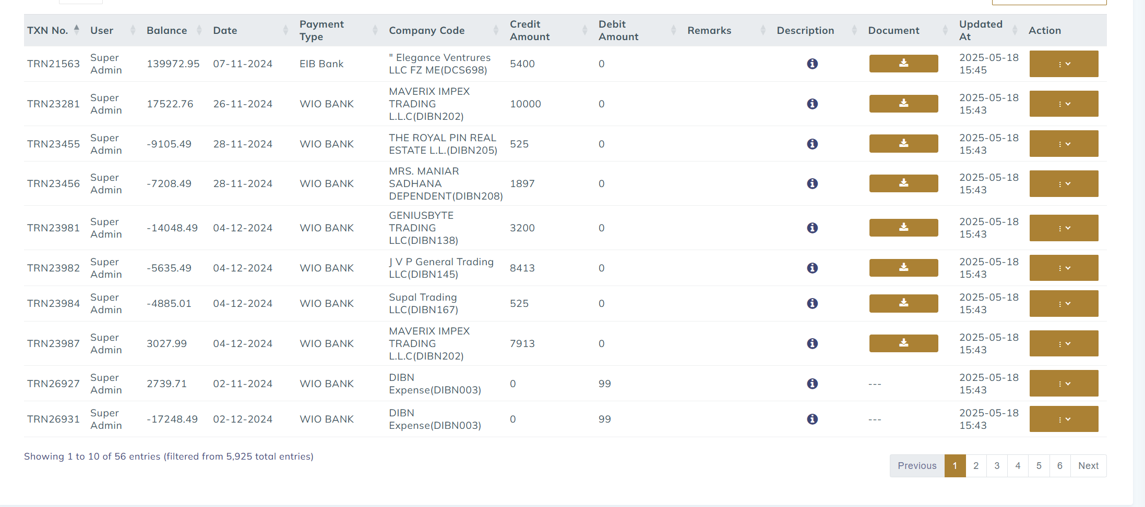
Dibn company wio bank I have servched only 6 pages shows and its actul almost 70 pages,
17. while we are editing entry documents automatically its remove from system.
18.

